int_bazaarvoice

Version 6.0.3



Summary

This document provides technical instructions for installing the Demandware Integration LINK integration that lets you integrate Bazaarvoice (BV) solutions with a Demandware storefront. This document is intended for individuals who possess at least a general understanding of the following topics:

  - Web development
  - Demandware UX Studio integrated development environment (IDE)
  - Bazaarvoice Ratings & Reviews (R&R) or Question & Answer (Q&A)
  - Interface components

Component Overview

Functional Overview

Bazaarvoice maintains a pre-built integration into the Demandware platform. This pre-built integration is delivered in the form of a Demandware LINK cartridge.
The cartridge is supplied “as-is” and is intended to function as a starter kit for clients to implement Bazaarvoice. It includes support for commonly required integration points, but does not include pre-built functionality for the exhaustive list of Bazaarvoice features. This cartridge may need to be customized by the client in order to implement functionality not included in the cartridge.

The Demandware LINK integration supports the following Bazaarvoice (BV) feature set:

- Ratings & Reviews
  - Submission
  - Display
  - Hosted Inline Ratings on Category & Search Results pages
  - Post-Interaction Email (PIE)
  - Bazaarvoice SEO
- Question & Answer
  - Submission
  - Display
  - Integration at Product Page level
  - Bazaarvoice SEO
- ROI beacon
  - Tracks transaction data when orders are placed.
  - Replaces the need for the Post-Interaction-Email feed.

NOTE: As of April, 2012, Bazaarvoice deprecated support for the Active Profiles product. The Demandware LINK cartridge may contain references to support Active Profiles. These references should be ignored. No attempt should be made to implement Active Profiles using the LINK cartridge.

The Demandware LINK Integration, which is also referred to as the Bazaarvoice (BV) cartridge, provides the following integration points with Bazaarvoice (BV) solutions:

- Demandware Storefront functionality
  - Ratings & Reviews (R&R)
  - Question & Answer (Q&A)

- For storefront functionality to work properly, the following integration would be set up in business manager
  - Product export feed generation
  - Post-Interaction-Email (PIE) feed generation (Note: purchase data received by Bazaarvoice via the ROI beacon feature can replace the need to enable the purchase feed export. Contact Bazaarvoice for more details.)

Use Cases

- Ratings & Reviews
List the use cases and appropriate action take listed below:
Use Case Scenarios | Result
The merchant implement Ratings and Reviews service from BV | - User will be able to see a summary of ratings on the product detail page.  - Clicking on the number rating or number of reviews will scroll the page to the reviews tab.  - Clicking on the Write a Review button will open a review submission modal. A review and rating can be submitted through this form.  - User will be able to read full reviews within a tab on the product page.  - Clicking on the Write a Review button will open a review submission modal. A review and rating can be submitted through this form.

- Question & Answer
List the use cases and appropriate action take listed below:
Use Case Scenarios | Result
The merchant implement Question and Answer content service from BV | - User will be able to see a summary of questions and answers on the product detail page.  - Clicking on the number of questions or number of answers will scroll the page to the Questions & Answers tab.  - Clicking on the Ask a question button will open a question submission modal. A question can be submitted through this form.  - User will be able to read full questions and answers within a tab on the product page.  - Clicking on the Ask a question button will open a review submission modal. A question can be submitted through this form.  - Clicking on an Answer this Question button for any question, the user can submit an answer to another user’s question.

- Hosted Inline Ratings
List the use cases and appropriate action take listed below:
Use Case Scenarios | Result
The merchant implement Hosted Inline Ratings service from BV | User will be able to view inline star ratings on the category/search product grid.

- Product feed
List the use cases and appropriate action take listed below:
Use Case Scenarios | Result
The merchant implement Product Catalog Export Feed to BV | A scheduled job must be set up to send product and category data to BV. After the job is set up and executed, it can be verified in the BV portal by navigating to Settings > Configuration Settings: Validate Product Feed, and clicking the “Invoke one-time import” link.

- ROI Beacon
List the use cases and appropriate action take listed below:
Use Case Scenarios | Result
The merchant implement ROI Beacon service from BV | When a user completes and order, the transaction data is shared with BV through the ROI Beacon on the confirmation page. This can be verified in the BV portal by navigating to Settings > Configuration Settings: ROI Beacon / PIE Tag Testing

Limitations, Constraints

Use of the Bazaarvoice Demandware LINK cartridge by itself does not grant nor enable use of the Bazaarvoice offerings (e.g. Ratings & Reviews, etc.). Bazaarvoice must separately enable the hosted Bazaarvoice SAAS services for the offerings to available on the Demandware platform. This may require a separate agreement with Bazaarvoice. Contact Bazaarvoice for details.

Compatibility

Compatible Demandware API version 10.6
Compatible Site Genesis version 14.3

Privacy, Payment

Customer will create a display name when leaving a review. The display name will be seen to public. Bazaarvoice does not access or display any other customer profile information.
The Bazaarvoice LINK cartridge itself is available free of charge. See “Limitations, Constraints” section for details regarding potential costs involved with enabling the Bazaarvoice hosted SAAS offerings.

Implementation Guide

Before you begin

You should consider the following topics before implementing the Bazaarvoice LINK cartridge:
- Mapping Demandware environments (development/staging/production) to Bazaarvoice environments (staging/production)
- Mapping Demandware Sites to Bazaarvoice Instances.

Mapping Demandware Instance Types to Bazaarvoice Environments

The following diagram illustrates how Demandware and Bazaarvoice environments map.
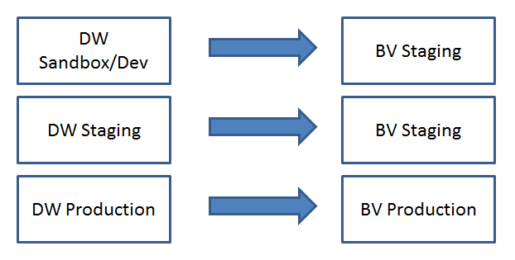

Mapping Demandware Sites and Locales to Bazaarvoice Instances and Locales

The Bazaarvoice Demandware LINK cartridge is architected in the following way:
- Each Demandware Site requires a separate Bazaarvoice instance with which to integrate
- Each Bazaarvoice Instance can support n Locales and n Deployment Zones
- Locales within a given Demandware Site can be mapped to a Locale + Deployment Zone combination within a particular Bazaarvoice instance
- Bazaarvoice supports only [language]_[country] locale values (e.g. en_US, fr_FR, etc.). Demandware supports both [language] (e.g. de) as well as [language]_[country] locale values (e.g. en_US, fr_FR, etc.). You can map a language-only Demandware Locale to a language-country combination for Bazaarvoice (e.g. de maps to de_DE).
The following diagram illustrates this concept:
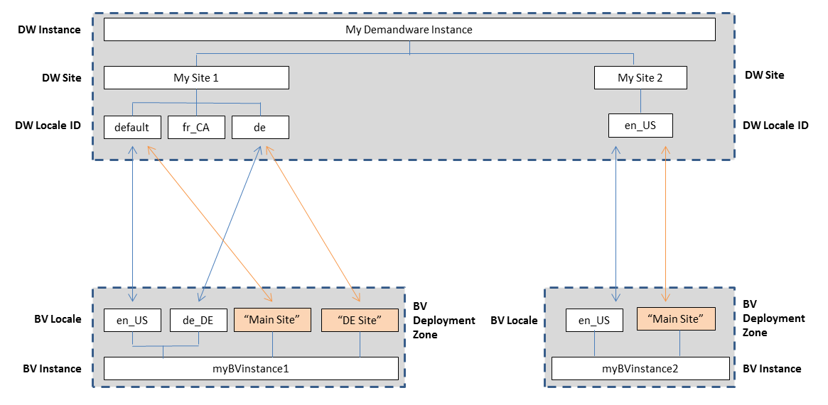

Multi-site Integrations

If a Demandware client wants to integrate Bazaarvoice into multiple Demandware Sites within a single Demandware instance, the following considerations should be made:
- There must exist a separate Bazaarvoice instance for each Demandware Site.
- Custom Site Preferences must be configured separately for each Demandware Site.
- The Bazaarvoice LINK Cartridge must be associated with each desired Demandware Site.
- Scheduled jobs only need to be created once, but must be associated with each Demandware Site. See the following illustration.

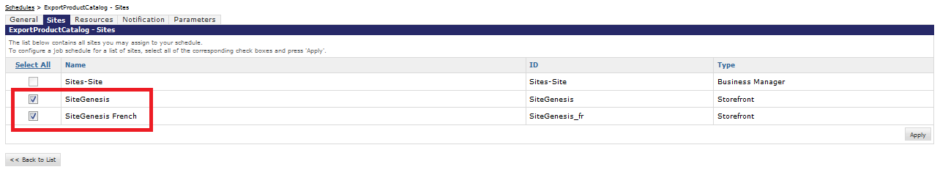

Task Sequence

The following is the typical sequence of tasks.
- Determine how your Demandware environment should map to Bazaarvoice (see section above); determine how many Bazaarvoice instances are required and which locales should be enabled for each Bazaarvoice instance
- Request Bazaarvoice Hosted Services be enabled, and retrieve required settings from Bazaarvoice
- Request a copy of the Bazaarvoice Demandware LINK cartridge
- Install the cartridge
- Register the cartridge with appropriate Demandware Sites
- Configure Custom Site Preferences (“Bazaarvoice Settings”)
- Create scheduled jobs
  - Product Feed Export
  - Purchase Feed Export (if applicable)
- Update product page templates
- Update category page templates (if applicable)
- Run product feed export process
- Contact BV to generate test content in staging
- Test

Requesting Bazaarvoice to Provision Hosted Services

Use of the Bazaarvoice Demandware LINK cartridge by itself does not grant nor enable use of the Bazaarvoice offerings (e.g. Ratings & Reviews, etc.). Bazaarvoice must separately enable the hosted Bazaarvoice SAAS services for the offerings to available on the Demandware platform. This may require a separate agreement with Bazaarvoice.

Complete the following steps:
- Contact a Bazaarvoice representative with the following information (for each Demandware Site) to provision Bazaarvoice hosted services:
  - Number of Bazaarvoice instances required
  - Suggested Client/Brand Name (for each instance)
  - Domain (for each instance)
  - Locale(s) required (for each instance)
- Request login credentials (Client Name and FTP password) for each BV instance.

Getting a Copy of the LINK Cartridge

Contact Bazaarvoice for the latest LINK cartridge. Though the Demandware LINK marketplace lists the cartridge, by sourcing the cartridge through Bazaarvoice, Bazaarvoice can track the usage of the cartridge and issue fixes to clients using potentially affected version of the cartridge.

Installing the LINK Cartridge

Complete the following steps to install the cartridge.

Initial Install

See the Demandware documentation for adding a cartridge to your storefront: https://documentation.demandware.com/display/DOC125/Adding+an+existing+cartridge+to+your+storefront

Note: You must also register the cartridge with the Business Manager site in order to run the Bazaarvoice jobs. Navigate to Administration > Sites > Manage Sites > Business Manager > Settings tab.

Registering the Cartridge with individual Demandware Sites

- Navigate to Administration > Sites > Manage Sites > [SiteName] > Settings tab.
- Add “:int_bazaarvoice” to the effective cartridge path.
- Click “Apply”.

Importing Metadata

Complete the following steps to import the Bazaarvoice metadata.

- Navigate to Administration > Site Development > Site Import & Export
- In the Import section,
  - Select Local.
  - Browse to the file, and click Upload.
- Click Back to get back to the Import & Export screen.
- Click Import in the Meta Data section.
- The bv metadata file is displayed in the list.
- Select the option button for the bv metadata file.
- Click Import.

After import, these system definition attributes and custom definition attributes should appear in the system.

System object definitions

- Order:
  - bvSentInPPEFeed - Whether or not the order was already sent in Bazaarvoice PPE feed

Site preferences

- Bazaarvoice Settings – Bazaarvoice Settings
  - bvEnvironment_C2013
  - bvCustomerName_C2013
  - bvFTPPassword_C2013
  - bvDeploymentZone_C2013
  - bvLocaleMapping_C2013
  - bvEnableRR_C2013
  - bvRRShowReviewsTabJavascript_C2013
  - bvEnableInlineRatings_C2013
  - bvEnableAA_C2013
  - bvAAShowReviewsTabJavascriptPDP_C2013
  - bv_EnableROIBeacon_C2013
  - bvEnableCloudSEO_C2013
  - bvCloudSEOKey_C2013
  - bvEnableProductFeed_C2013
  - bvProductImageType_C2013
  - bvEnablePurchaseFeed_C2013
  - bvOrderImageType_C2013
  - bvPurchaseFeedTriggeringEvent_C2013
  - bvAdminEmail_C2013

General Bazaarvoice Setup

A set of general steps must be completed regardless of which Bazaarvoice feature (e.g. Ratings & Reviews, Question & Answer) is being implemented.

Configuring Custom Site Preferences for Client Name and FTP access
Complete the following steps.
- Navigate to Site > (select desired Demandware Site) > Site Preferences > Custom Preferences > Bazaarvoice Settings
- Select the appropriate Instance (Sandbox/Development, Staging, Production), and click Apply.
- Select the appropriate Bazaarvoice Environment value (Staging or Production).
- Set the following using the values as provided by your Bazaarvoice representative:
  - Client Name
  - FTP Password
- Click Apply.

Configuring Locale Mappings and Deployment Zone
Complete the following steps:
- Determine the list of Demandware Locale IDs that should be integrated with Bazaarvoice.
  - In the Demandware Business Manager, click Sites > [select desire Site] > Site Preferences > Locales.
  - Note the desired Demandware Locale IDs:
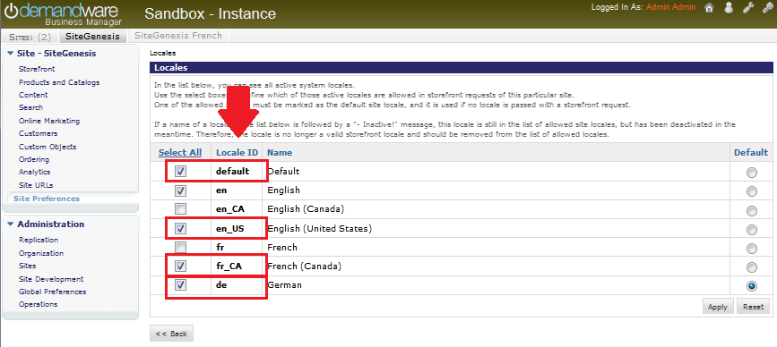
- Determine the Deployment Zone and Locales enabled in the Bazaarvoice platform:
  - Login to http://login.bazaarvoice.com.
  - Click Settings > Manage Applications.
  - Note your Deployment Zone name. The default Bazaarvoice Deployment Zone is named “Main Site”. Alternatively, you can create a new Deployment Zone by clicking New Deployment Zone. You can have more than one Deployment Zone.
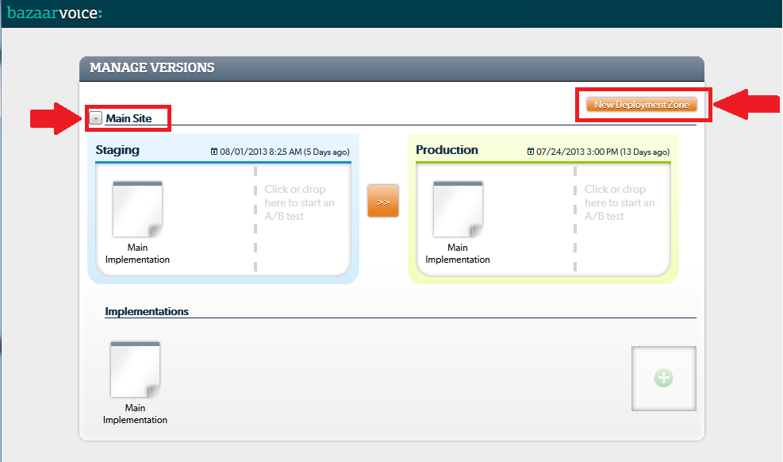

  - Complete the following steps to identify the list of enabled locales.
  - Select your desired Implementation.
  - Select Global in the upper menu bar.
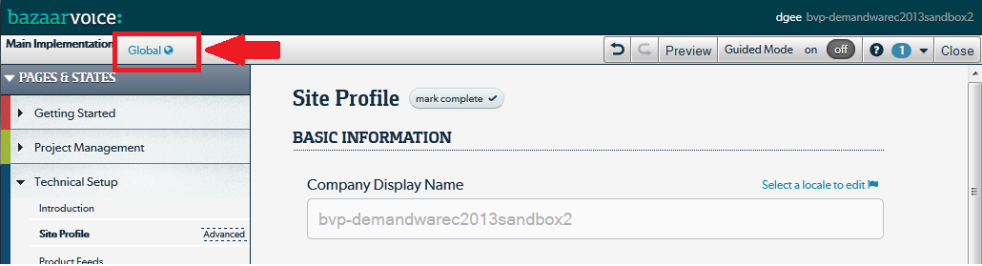
  - Click Select a locale to edit. The pull down list will display the enabled locales.
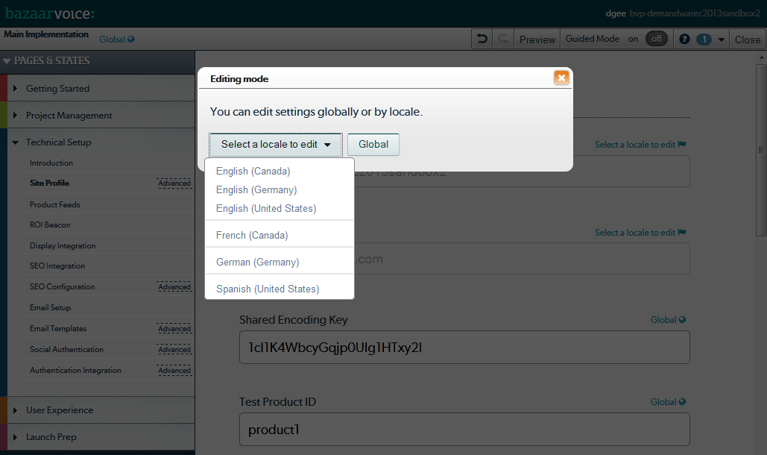
  - Contact your Bazaarvoice representative if you need additional locales enabled.
- Determine your mappings. Example:
Demandware Locale ID | Bazaarvoice Locale | Comment
default | en_US | The “default” DW Locale can be mapped
en | (not mapped) | A DW Locale ID can be left unmapped
en_US | en_US | A BV Locale can be included in more than one mapping
fr_CA | fr_CA | Typical mapping
De | de_DE | Language-only (de) DW Locales must be mapped to a Language-Country (de_DE) BV Locales

- Navigate to Site > (select desired Demandware Site) > Site Preferences > Custom Preferences > Bazaarvoice Settings.
- Enter your Deployment Zone.
- Configure a Locale Mapping for each desired mapping (click Add Another Value to create additional mappings) using the following format:
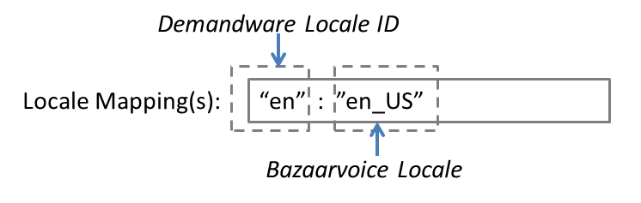
- Click Apply.
Follow the remainder of the documentation to configure the remaining custom site preferences.

Bazaarvoice SEO
Complete the following steps to enable the Bazaarvoice SEO solution. The Demandware LINK cartridge utilizes the Cloud SEO method.

A Cloud SEO Key is required to implement the Bazaarvoice SEO solution. Complete the following to locate the key:
- A Cloud SEO Key is required to implement the Bazaarvoice SEO solution. Complete the following to locate the key:
  - Login to http://login.bazaarvoice.com.
  - Click Settings > Manage Applications.
  - Select your desired implementation.
  - Select Global in the upper left menu bar.
  - Click SEO Configuration in the left navigation panel.
  - Ensure that Root Folder is set to “{deploymentzone}-{locale}”.
  - Note the Cloud Key value.
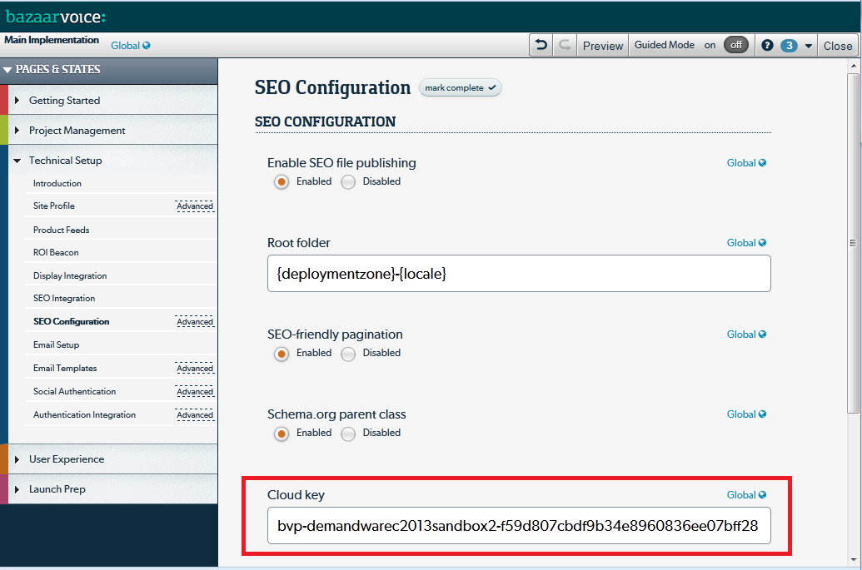
- Configure the custom site preferences:
  - Navigate to Site > (select desired Demandware Site) > Site Preferences > Custom Preferences > Bazaarvoice Settings
  - Select the appropriate Instance (Sandbox/Development, Staging, Production), and click Apply.
  - Check the Enable Cloud SEO checkbox.
  - Enter your Cloud SEO Key value.
  - Click Apply.
- Update your Demandware product page templates (see the section “Updating Demandware Product Page templates”).

Product Catalog Feed Export

The following sections describe the steps the product catalog feed export process.

- Set Custom Site Preferences for the product catalog feed export
- Create a Scheduled Job

Product Catalog Feed Export Custom Site Preferences

Complete the following steps to configure the Product Feed Export Custom Site Preferences.

- Navigate to Site > (select desired Demandware Site) > Site Preferences > Custom Preferences > Bazaarvoice Settings
- Select the appropriate Instance (Sandbox/Development, Staging, Production), and click Apply.
- Check the Enable Product Feed checkbox.
- Enter Product Feed Image Type. Typical values are “large”, “medium”, and “small”. The value must match an existing image size type defined in Demandware.
- Click Apply.
 | FTP Hostname Override for C7 Clients  By default, the Demandware cartridge attempts to upload feeds to sftp.bazaarvoice.com (production) and sftp-stg.bazaarvoice.com (staging).  Bazaarvoice clients provisioned on cluster #7 (i.e. c7) must configure an override to connect to C7 SFTP servers. See the section “Advanced Topics” for details.

Setup Schedule Job to Export Product Catalog Feed

A scheduled job must be created to export the product catalog feed on a recurring daily basis.

- Navigate to Administration > Operations > JobSchedules.
- Click New.
- On the General tab, enter the following:
  - Name: ExportProductFeed
  - Select the Enabled checkbox.
  - Execution Scope: Sites
  - Pipeline: BazaarvoiceData
  - Start Node: ExportProductCatalog
  - Select Recurring Interval and set schedule to daily.
- On the Sites tab, select the desired Site(s).
- (For Site Genesis 2 only) On the Resources tab, select the Product and Catalog resources.
- On the Notification tab,
  - Select the Enabled check box.
  - For Threshold, select the ERROR and HANG check boxes
  - In the (email) To: field, enter the email address(es) for the appropriate client representatives.
- Click Apply.

ROI beacon
Complete the following steps to enable the ROI beacon. The Demandware LINK cartridge implements the beacon version intended for online transaction orders.

Configure ROI Beacon Site Preferences
Complete the following steps.
- Navigate to Site > (select desired Demandware Site) > Site Preferences > Custom Preferences > Bazaarvoice Settings
- Select the appropriate Instance (Sandbox/Development, Staging, Production), and click Apply.
- Check the Enable ROI beacon checkbox.
- Click Apply.

Adding ROI Beacon to the Order Confirmation Page Template
For all versions of the LINK cartridge, add the following code to the template “pt_orderconfimation.isml”, before the closing </body> tag:
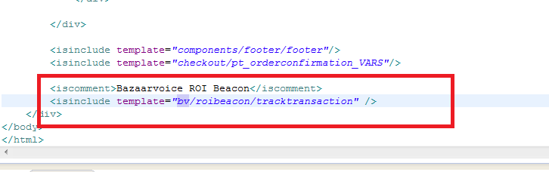
<isinclude template="bv/roibeacon/tracktransaction"/>

Purchase Feed Export

The following sections describe the steps the purchase feed export process.

- Set Custom Site Preferences for Purchase Feed Export
- Create a Scheduled Job

Note: purchase data received by Bazaarvoice via the ROI beacon feature can replace the need to enable the purchase feed export. Contact Bazaarvoice for more details.

Purchase Feed Export Custom Site Preference

Complete the following steps to configure the Purchase Feed Export Custom Site Preferences.

- Navigate to Site > (select desired Demandware Site) > Site Preferences > Custom Preferences > Bazaarvoice Settings
- Select the appropriate Instance (Sandbox/Development, Staging, Production), and click Apply.
- Set the following:
  - Check the Enable Purchase Feed checkbox.
  - Purchase Feed Triggering Event, select Purchase or Shipping.
  - Enter Purchase Feed Image Type. Typical values are “large”, “medium”, and “small”. The value must match an existing image size type defined in Demandware.
- Click Apply.

FTP Hostname Override for C7 Clients
By default, the Demandware cartridge attempts to upload feeds to sftp.bazaarvoice.com (production) and sftp-stg.bazaarvoice.com (staging).

Bazaarvoice clients provisioned on cluster #7 (i.e. c7) must configure an override to connect to C7 SFTP servers. See the section “Advanced Topics” for details.

Setup Schedule Job to Export Purchase Feed

A scheduled job must be created to export the purchase feed on a recurring daily basis.

- Navigate to Administration > Operations > JobSchedules.
- Click New.
- On the General tab, enter the following:
  - Name: ExportPurchaseData
  - Select the Enabled checkbox.
  - Execution Scope: Sites
  - Pipeline: BazaarvoiceData
  - Start Node: ExportPurchaseData
  - Select Recurring Interval and set schedule to daily.
- On the Sites tab, select the desired Site(s).
- On the Notification tab (or on the Resources tab for Site Genesis 2),
- Select the Enabled check box.
- For Threshold, select the ERROR and HANG check boxes.
- In the (email) To: field, enter the email address(es) for the appropriate client representatives.
- Click Apply.

Ratings & Reviews Display

This section describes the steps required to setup the display of Ratings & Reviews.

Note:
Complete General Setup First!

Complete the steps detailed in the “General Bazaarvoice Setup” section of this document before completing this section.

Adding Ratings & Reviews to the Product Page

The following sections describe the steps to implement R&R on the product page.

Configuring Ratings & Review Site Preferences
Complete the following steps.
- Navigate to Site > (select desired Demandware Site) > Site Preferences > Custom Preferences > Bazaarvoice Settings
- Select the appropriate Instance (Sandbox/Development, Staging, Production), and click Apply.
- Check the Enable Ratings & Reviews checkbox.
- Click Apply.
Note: you must also complete the steps in section “Mapping Demandware Locales to Bazaarvoice Deployment Zones and Locales”

Updating Demandware Product Page Templates

To integrate the R&R display templates, add the following <isinclude> elements to the various templates that comprise the product information page.

- Header Includes
- Ratings Summary Include
- Reviews Include

Ratings Header Include

Place this <isinclude> element in the product ISML template file that contains your HTML head. If your store is based on SiteGenesis, add this element to pt_productdetails.isml immediately before the close of the head tag.

<isinclude template="bv/display/headerincludes"/>
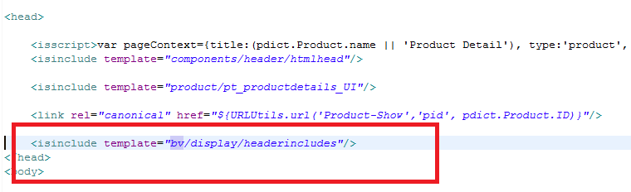

Ratings Summary Include

Place the following <isinclude> element in the product information ISML template in which you want to display the ratings summary block. If your store is based on SiteGenesis, add this element to productcontent.isml, replacing the existing include for product/components/reviewsmini.

<isinclude template="bv/display/rr/reviewsummary"/>
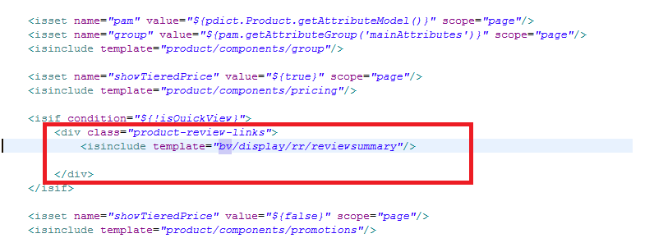

Reviews Include

Place the following <isinclude> element in the product information ISML template in which you want to display the actual reviews. If your store is based on SiteGenesis, add this element to producttopcontent.isml, replacing the existing include for product/components/reviews. The <div> tag id needs to match with the link location on tab, whichis “tab4” in Site Genesis.

<isinclude template="bv/display/rr/reviews"/>

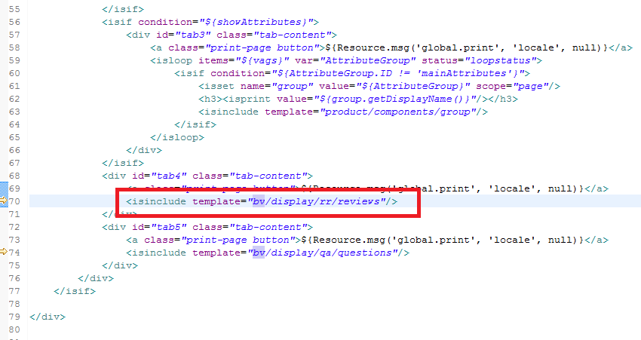

Putting Review content behind a Tab

When review content is behind a tab, you must properly include JavaScript in a custom site preference.

- Navigate to Site > (select desired DW Site) > Site Preferences > Custom Site Preferences > Bazaarvoice Settings
- Select the appropriate Instance (Sandbox/Development, Staging, Production), and click Apply.
- Add the following code to the Show Reviews Tab Javascript function (product page)Javascript” jQuery('.product-tabs').tabs('select', 'tab4');
- Click Apply.

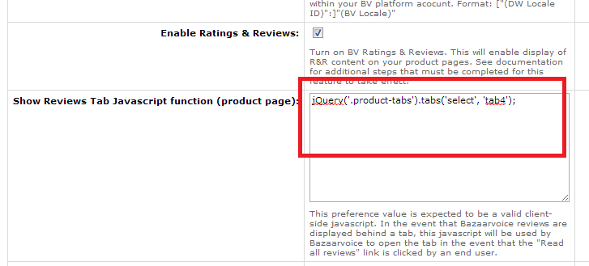

Adding Inline Ratings to Category and/or Search Results Pages

The following sections describe the steps to implement Inline Ratings.

- Configure Custom Site Preferences
- Update Category page and Search Results page templates

Configure Inline Ratings Site Preferences
Complete the following steps.
- Navigate to Site > (select desired Demandware Site) > Site Preferences > Custom Preferences > Bazaarvoice Settings
- Select the appropriate Instance (Sandbox/Development, Staging, Production), and click Apply.
- Check the Enable Inline Ratings (JS-based) checkbox.
- Click Apply.

Updating Demandware Category and/or Search Results Templates

Ratings Header Include

Place this <isinclude> element in the product ISML template file that contains your HTML head for the search result and category pages. If your store is based on SiteGenesis, add this element to pt_productsearchresult.isml immediately before the close of the head tag.

<isinclude template="bv/display/headerincludes"/>
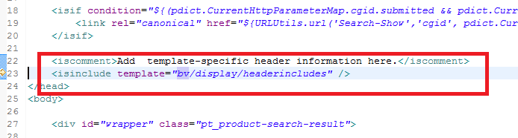

Place the following <isinclude> element in any pages in which you want the inline ratings (e.g. overall ratings, number of reviews, overall star rating image) to appear next to a product, such as a search page or a category page that lists your products. If your store is based on SiteGenesis, add this element to productsearchhittile.isml, replacing the existing include for product/components/reviewsmini.

<isinclude template="bv/display/rr/inlineratings-hosted"/>
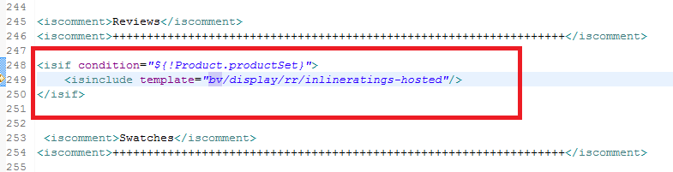

Once all of the tiles are rendered, a call is needed to initialize all of the inline ratings in the grid. Place the following <isinclude> element at the end of the productgrid.isml template.

<isinclude template="bv/display/rr/inlineratings-hosted-init"/>
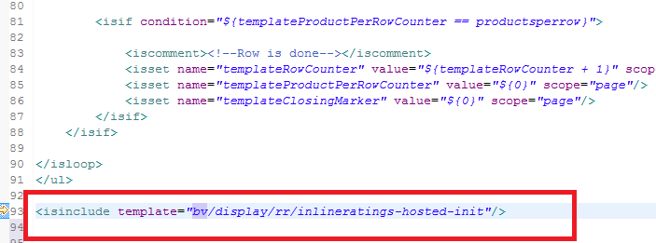

Question and Answer Display

This section describes the steps required to setup the display of Question & Answers.

Note:
Complete General Setup First!

Complete the steps detailed in the “General Bazaarvoice Setup” section of this document before completing this section. Note that the Bazaarvoice Submission Container page setup is included in these previously covered sections.

Configuring Question and Answer Site Preferences
Complete the following steps.
- Navigate to Site > (select desired Demandware Site) > Site Preferences > Custom Preferences > Bazaarvoice Settings
- Select the appropriate Instance (Sandbox/Development, Staging, Production), and click Apply.
- Check the Enable Question & Answer checkbox.
- Click Apply.
- Note: you must also complete the steps in section “Mapping Demandware Locales to Bazaarvoice Deployment Zones and Locales”

Adding Question & Answer to the Product Page

The following sections describe the steps to implement Question & Answer on the product page.

Updating Demandware Product Page Templates

To integrate the Q&A display templates, add the following <isinclude> elements to the various templates that comprise the product information page.

- Header Includes
- Question Summary Include
- Questions (and Answers) Content Include

Question and Answer Header Include

Place this <isinclude> element in the product ISML template file that contains your HTML head. If your store is based on SiteGenesis, add this element to pt_productdetails.isml immediately before the close of the head tag.

<isinclude template="bv/display/headerincludes"/>

Question And Answer Summary Include

Place the following <isinclude> element in the product information ISML template in which you want to display the ratings summary block. If your store is based on SiteGenesis, add this element to productcontent.isml.

<isinclude template="bv/display/qa/questionsummary"/>
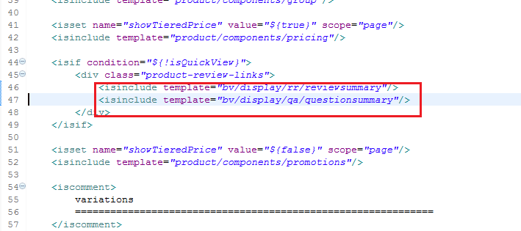

Question and Answer Content Include

Place the following <isinclude> element in the product information ISML template in which you want to display the actual Q&A content. If your store is based on SiteGenesis, add this element to producttopcontent.isml.

<isinclude template="bv/display/qa/questions"/>

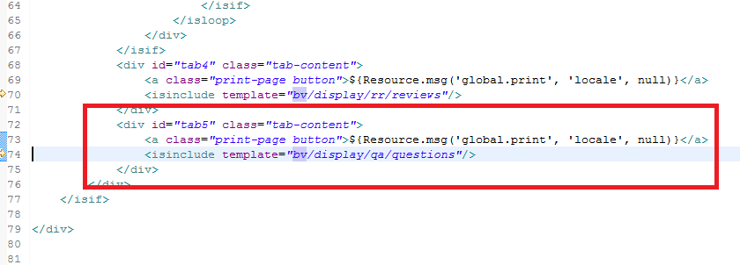

Putting Question and Answer content behind a tab

To add a questions tab on product page (and if your store is based on SiteGenesis) code must be included on the product page, producttopcontent.isml. The <div> tag id needs to match with the link location on tab.

Include the following line in tabs-menu as a list item:

<li><a href="#tab5">${Resource.msg('product.tab5','product',null)}</a></li>

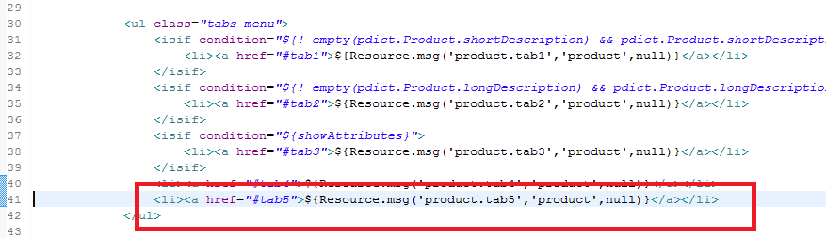

Include the following code after tab4:

<div id="tab5" class="tab-content">
<a class="print-page button">${Resource.msg('global.print', 'locale', null)}</a>
<isinclude template="bv/display/qa/questions"/>
</div>

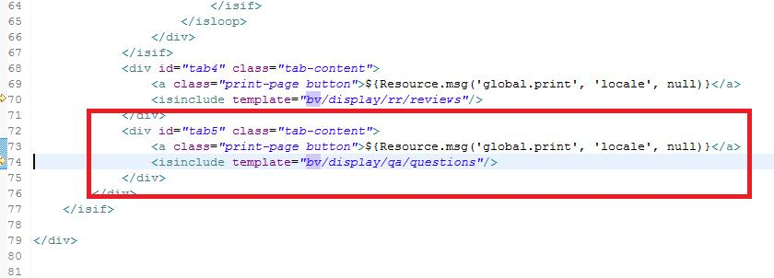

Add tab display labels in the resource file product.properties.
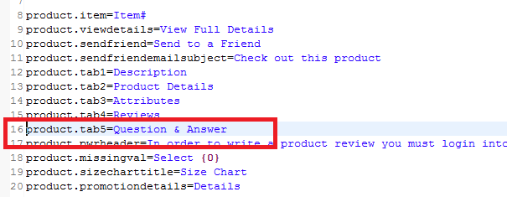

Include JavaScript in a custom site preference.

- Navigate to Site > (select desired DW Site) > Site Preferences > Custom Site Preferences > Bazaarvoice Settings
- Select the appropriate Instance (Sandbox/Development, Staging, Production), and click Apply.
- Add the following code to the Show Q&A Tab Javascript (Product Page) preference: jQuery('.product-tabs').tabs('select', 'tab5');Click Apply.

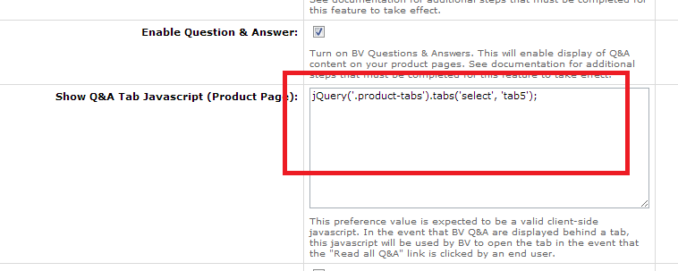

Submission
The Bazaarvoice DW cartridge supports the following best practice submission-related features:
- Bazaarvoice hosted authentication
- Bazaarvoice submission page (pop-up page without a DW-created submission container page)

Because these best practices are completely powered by Bazaarvoice, the DW cartridge contains no specific functionality (i.e. code) to support this functionality.

Advanced topics

The following are special considerations to be aware of.

Upgrading from a previous Bazaarvoice LINK Cartridge Version

The following are the recommended steps to upgrade to a newer version of the Bazaarvoice LINK cartridge.

Complete the following steps in sandbox/staging (making changes in staging will not affect production until replication):
- Disable replication.
- Completely delete the cartridge from the Site.
- Completely delete the exisiting Bazaarvoice-related metadata on the Site.
- Delete all existing Bazaarvoice-related Scheduled Jobs.
- Install the new cartridge (including importing the new metadata and setting up the new Scheduled Jobs) to the site according to the Bazaarvoice documention.
- Test the new cartridge functionality (sandbox/staging).

To push changes to production:
- In each of the appropriate Custom Site Preferences, select an instance type "production" and enter the appropriate settings.
- Execute data replication.
- Execute code replication.

FTP Hostname Override for C7 Clients

By default, the Demandware cartridge attempts to upload feeds to sftp.bazaarvoicecom (production) and sftp-stg.bazaarvoice.com (staging).

Bazaarvoice clients provisioned on the C7 cluster must complete the following steps:

Open the file "int_bazaarvoice/cartridge/scripts/lib/libConstants.ds" and edit the two variables defined on lines 15 and 16:
- BV_Constants.FTPHostStaging = "sftp7-stg.bazaarvoice.com";
- BV_Constants.FTPHostProduction = "sftp7.bazaarvoice.com";

Product Family Override

By default, the Demandware cartridge attempts collect and distribute content at the master product level. This can cause problems with hosted inline ratings when color slicing is used, or variations are assigned to the same category as their master.

Bazaarvoice clients who wish to display color sliced product tiles must complete the following steps to enable the use of product families:

Open the file "int_bazaarvoice/cartridge/scripts/lib/libConstants.ds" and edit the two variables defined on lines 49 and 51:
- BV_Constants.EnableProductFamilies = true;
- BV_Constants.UseVariantID = true;

Appendix: Examples

The following are example integrations between a Bazaarvoice sandbox account and a Demandware Site Genesis implementation using the Demandware starter store.

Example Category Page

This example illustrates Inline ratings statistics next to each tiled product.

http://bazaarvoice03.tech-prtnr-na01.dw.demandware.net/on/demandware.store/Sites-SiteGenesis-Site/en_US/Search-Show?cgid=mens-clothing-suits

Example Product Page

This example illustrates the following:
- Bazaarvoice Ratings & Reviews (product level review content)
- Bazaarvoice Question & Answer (product level Q&A content)

http://bazaarvoice03.tech-prtnr-na01.dw.demandware.net/on/demandware.store/Sites-SiteGenesis-Site/en_US/Product-Show?pid=25686364

Operations, Maintenance

Data Storage

The export and import feeds will be stored under webdav/Sites/Temp while the jobs are running and deleted when the jobs finished. There will not be feeds storage on Impex.

Availability

BV hosted services perform with an uptime of 99.9% reliability. Additionally, the Bazaarvoice services are designed in such a way to gracefully fail without impact on the Demandware webstore performance. If the event of failure, Bazaarvoice functionality will simply cease to exist on the target pages.

Support

Contact partner-support@bazaarvoice.com regarding this LINK cartridge.

Known Issues

Release History

Version | Date | Changes
5.1.1 |  | - Quota violation fix for plugin version 5.1  - Included functionality to open tab on PDP when clicking “read all reviews” (analogous fixes for displaying Ask & Answer and Stories content behind tabs)  - Removed default value for “Bazaarvoice Encoding Key” preference  - Removed global preference for bvdisplaycode (no longer used)  - Timestamp automatically appended to Order Feed XML filename  - Ratings statistics set to zero for all products prior to new statistic values being imported from XML ratings feed
5.2 |  | - Support for multi-locale DW sites integrating with single BV instance  - Additional data elements in product catalog feed for BV network functionality  - Support for configurable image sizes in product catalog and orders feed generation processes  - Remove issue with incorrect display on Search Results pages
6.0.3 |  | - Conversations 2013 platform support  - Hosted inline ratings  - Cloud based Bazaarvoice SEO integration  - ROI Beacon  - Simplified Site preferences by moving many configuration variables to a script file, and downsizing to a single preference group  - Fixed Brand elements in the product and purchase feeds  - Optional Product Family support

? int_bazaarvoice, version 6.0.3

